FRAUD DETECTION SMART GLASSES
Analysis Model Report



Presented by:

Jeevant Verma - 102303100
Aniket Saxena - 102303278
Lakshita Gupta - 102303505
Mannat Kaur Miglani - 102303720
Yuvansh Pathak - 102317061

Department: CSED CPG No: 311
Mentor: Dr. Tarunpreet Bhatia (Associate Professor, CSED)
Thapar Institute of Engineering and Technology
Date: 22/03/2026

1. Product Perspective

1.1 Initial Visualization / Look and Feel
The product is a wearable smart glasses device designed to function as a real-time, multi-modal identity fraud detection system. The verification officer wears the glasses during live identity interactions (banking, border control, KYC, etc.). The glasses are visually unobtrusive and closely resemble standard prescription glasses, integrating a miniature camera, microphone, and bone conduction transducer within the frame.
The device captures audio and video continuously during a verification interaction. Lightweight TinyML models process the raw signals on-device (on the ESP32-S3 microcontroller) to extract compressed feature vectors not raw data thereby ensuring privacy. These feature vectors are transmitted wirelessly to a paired smartphone, which relays them securely to a cloud backend. The cloud runs the full multi-modal fraud detection pipeline and returns a fraud risk score. The officer receives a discreet, real-time alert through bone conduction (vibration-based audio) without visually or audibly disrupting the interaction.

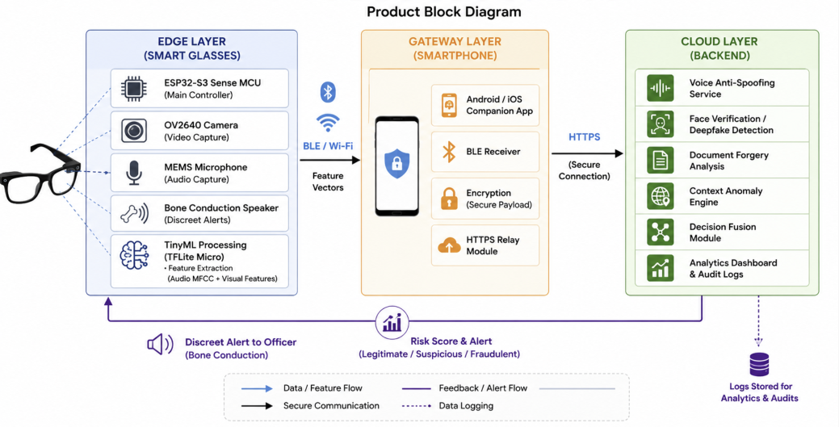

1.2 Block Diagram - System Components
The system is organized across three layers:

Layer | Components | Role
Edge Layer (Smart Glasses) | ESP32-S3 Sense MCU, OV2640 Camera, MEMS Microphone, Bone Conduction Speaker | Capture audio/video; run TinyML feature extraction; transmit feature vectors; deliver alerts
Gateway Layer (Smartphone) | Android/iOS companion app, BLE/Wi-Fi receiver, HTTPS relay module | Receive feature vectors from glasses; encrypt and forward to cloud backend securely
Cloud Layer (Backend) | Voice anti-spoofing service, Face matching service, Document analysis service, Context anomaly engine, Decision fusion module, Analytics dashboard | Run multi-modal fraud detection models; fuse outputs; score risk; log analytics; send alert back

Data Flow Summary:
- ESP32-S3 captures audio via microphone and video via OV2640 camera
- TensorFlow Lite Micro models extract MFCC (audio) and visual feature vectors on-device
- Feature vectors transmitted via BLE or Wi-Fi to paired smartphone
- Smartphone gateway encrypts payload and forwards via HTTPS to cloud API
- Cloud runs voice anti-spoofing, deepfake face detection, document forgery detection, and context anomaly checks in parallel
- Decision fusion module combines all outputs into a unified risk score
- Risk score and alert sent back to glasses; officer notified via bone conduction speaker
- Session data and verdict logged to analytics dashboard

2. Use Case Diagrams & Templates
The system has three primary actors:
- Verification Officer (wears the smart glasses; initiates and receives results of identity verification)
- Subject (the person being verified; interacts with the officer)
- System Administrator (manages configuration, views analytics and audit logs)

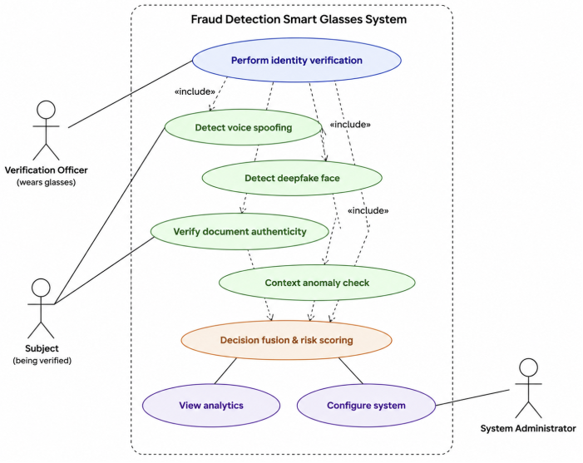

2.1 Use Case Relationships Summary
Use Case | Triggering Actor | Relationship
UC-01: Perform Identity Verification | Verification Officer | Primary trigger use case
UC-02: Detect Voice Spoofing | System (via UC-01) | «include» from UC-01
UC-03: Detect Deepfake Face | System (via UC-01) | «include» from UC-01
UC-04: Verify Document Authenticity | Officer + System | «include» from UC-01
UC-05: Context Anomaly Check | System (via UC-01) | «include» from UC-01
UC-06: Decision Fusion & Risk Scoring | System | Aggregates UC-02 to UC-05
UC-07: View Analytics Dashboard | System Administrator | Independent
UC-08: Configure System Settings | System Administrator | Independent

2.2 Use Case Templates
UC-01: Perform Identity Verification
Use Case ID | UC-01
Use Case Name | Perform Identity Verification
Actor(s) | Verification Officer (primary), Subject (secondary)
Pre-conditions | Smart glasses powered on and paired to gateway; cloud backend reachable; subject is present
Normal (Main) Scenario | 1. Officer wears glasses and initiates a session. 2. Camera captures face; microphone captures voice. 3. TinyML extracts feature vectors on-device. 4. Vectors transmitted to gateway via BLE/Wi-Fi. 5. Gateway relays encrypted features to cloud. 6. Cloud runs all detection modules in parallel. 7. Decision fusion produces unified risk score. 8. Officer receives discreet alert via bone conduction.
Alternate Flow | A1: Wi-Fi drop — system falls back to BLE. A2: Face not detectable (low light) — system prompts repositioning.
Extension Points | Extends to UC-02 (Voice), UC-03 (Face), UC-04 (Document), UC-05 (Context)
Post-conditions | Risk score logged; identity verified or flagged as suspicious/fraudulent

UC-02: Detect Voice Spoofing
Use Case ID | UC-02
Use Case Name | Detect Voice Spoofing
Actor(s) | System (triggered by UC-01)
Pre-conditions | Audio feature vector (MFCC/CQCC) extracted and received by cloud
Normal (Main) Scenario | 1. Cloud receives audio feature vector. 2. Anti-spoofing model classifies voice as live or synthetic (TTS/voice conversion/replay). 3. Output (live/spoofed + confidence score) forwarded to Decision Fusion.
Alternate Flow | A1: Confidence below threshold — flagged inconclusive; re-verification requested.
Extension Points | Feeds into UC-06 (Decision Fusion)
Post-conditions | Voice liveness verdict recorded in session log

UC-03: Detect Deepfake Face
Use Case ID | UC-03
Use Case Name | Detect Deepfake Face
Actor(s) | System (triggered by UC-01)
Pre-conditions | Visual feature vector extracted from OV2640 camera frames
Normal (Main) Scenario | 1. Cloud receives facial feature vector. 2. Face-to-ID matching (FaceNet/ArcFace) compares live face to ID photo. 3. Deepfake detection model identifies manipulated inputs. 4. Result and confidence sent to Decision Fusion.
Alternate Flow | A1: Off-angle or low-light capture — preprocessing applied before classification.
Extension Points | Feeds into UC-06
Post-conditions | Face authenticity verdict and confidence score recorded

UC-04: Verify Document Authenticity
Use Case ID | UC-04
Use Case Name | Verify Document Authenticity
Actor(s) | Verification Officer, System
Pre-conditions | Officer presents ID document within camera field of view; image captured
Normal (Main) Scenario | 1. Camera captures document image. 2. Features extracted on-device. 3. Cloud document PAD model checks for Moiré patterns, digital forgery, synthetic printing artifacts. 4. Authenticity verdict sent to Decision Fusion.
Alternate Flow | A1: Off-angle image — system requests better angle from officer.
Extension Points | Feeds into UC-06
Post-conditions | Document validity verdict recorded

UC-05: Context Anomaly Check
Use Case ID | UC-05
Use Case Name | Context Anomaly Check
Actor(s) | System
Pre-conditions | Session metadata (GPS/IP location, timestamp, transaction context) available
Normal (Main) Scenario | 1. System retrieves GPS/IP-based location. 2. Compares against subject's known transaction history. 3. Flags mismatches (impossible travel, unusual transaction patterns). 4. Anomaly score forwarded to Decision Fusion.
Alternate Flow | A1: No prior history — neutral score assigned; flagged as inconclusive.
Extension Points | Feeds into UC-06
Post-conditions | Contextual risk score appended to fusion input

UC-06: Decision Fusion & Risk Scoring
Use Case ID | UC-06
Use Case Name | Decision Fusion & Risk Scoring
Actor(s) | System
Pre-conditions | Outputs from UC-02, UC-03, UC-04, UC-05 all received
Normal (Main) Scenario | 1. Fusion module receives all sub-module scores. 2. Weighted fusion algorithm combines outputs. 3. Unified risk score produced. 4. Interaction classified: Legitimate / Suspicious / Fraudulent. 5. Alert sent back to glasses via bone conduction.
Alternate Flow | A1: One module times out - fusion proceeds with available scores plus penalty weight.
Extension Points | None
Post-conditions | Final risk verdict logged; real-time alert delivered to officer

UC-07: View Analytics Dashboard
Use Case ID | UC-07
Use Case Name | View Analytics Dashboard
Actor(s) | System Administrator
Pre-conditions | Admin authenticated; backend operational
Normal (Main) Scenario | 1. Admin logs into web dashboard. 2. Views fraud attempt statistics, session logs, trends over time. 3. Exports reports as required.
Alternate Flow | A1: Session data not loaded - admin retries or contacts backend team.
Extension Points | None
Post-conditions | Reports viewed and/or exported

UC-08: Configure System Settings
Use Case ID | UC-08
Use Case Name | Configure System Settings
Actor(s) | System Administrator
Pre-conditions | Admin has privileged system access
Normal (Main) Scenario | 1. Admin navigates to settings panel. 2. Updates alert thresholds, model versioning parameters, user roles. 3. Changes persisted to backend configuration store.
Alternate Flow | A1: Invalid configuration value - system rejects and prompts correction.
Extension Points | None
Post-conditions | Updated system settings persisted and effective

3. Complete Tasks and Subtasks
The following table identifies the complete set of tasks and their subtasks for the project lifecycle:

Task | Subtasks
T1. Project Planning | Define scope; conduct literature review; technology stack analysis; assign roles and responsibilities; set up project timeline
T2. System Architecture Design | Define edge-gateway-cloud communication protocol; design end-to-end data flow; define REST API contracts; select hardware components
T3. Data Collection & Preprocessing | Collect voice dataset (ASVspoof 2019 / 2024); collect face dataset (LFW, FaceForensics++); collect document dataset (SIDTD); apply preprocessing, normalization, and augmentation
T4. Voice Anti-Spoofing Model | Extract MFCC/CQCC features; train CNN or Transformer-based model on ASVspoof; validate against benchmark; optimize for accuracy
T5. Face Deepfake Detection Model | Prepare FaceForensics++ dataset; fine-tune FaceNet/ArcFace for face-to-ID matching; train deepfake detection classifier; validate against LFW benchmark
T6. Document Forgery Detection Model | Prepare SIDTD dataset; build document PAD model for Moiré, digital forgery, synthetic printing; train and validate
T7. TinyML Optimization | Convert trained models to TensorFlow Lite format; apply quantization; benchmark inference latency on ESP32-S3; validate within memory and SRAM constraints
T8. ESP32-S3 Firmware Development | Integrate OV2640 camera driver; integrate MEMS microphone driver; implement MFCC extraction pipeline; implement TFLite inference loop; implement BLE/Wi-Fi transmission module; implement bone conduction alert output
T9. Smartphone Gateway App | Develop Android/iOS companion app; implement BLE receiver; implement HTTPS API relay; implement return alert handler; implement encryption layer
T10. Cloud Backend Development | Build REST API endpoints for feature ingestion; integrate voice, face, and document detection services; build context/anomaly service; implement decision fusion engine; build analytics and reporting module
T11. Hardware Assembly | Mount ESP32-S3 to glasses frame; integrate camera at optimal capture angle; integrate microphone; attach bone conduction transducer; manage power supply and wiring; 3D-print/custom-fit enclosure
T12. System Integration | End-to-end data flow testing; latency measurement; validate sub-100ms on-device extraction target; validate end-to-end pipeline
T13. Design Optimization | Power consumption tuning; latency reduction; model accuracy vs. inference speed trade-off calibration
T14. Integration & Security Testing | Test with real deepfake samples; test with spoofed voice samples; test with forged documents; test under varied lighting/noise; encryption and data privacy testing
T15. Results Evaluation & Validation | Benchmark against ASVspoof, FaceForensics++; measure false positive/negative rates; document accuracy metrics; compare against related work
T16. Final Report & Documentation | Write full system documentation; prepare final capstone report; prepare final presentation

4. Swimlane / Activity Diagram
The swimlane activity diagram describes the end-to-end process flow across four lanes: Smart Glasses (Edge), Smartphone Gateway, Cloud Backend, and Officer/Admin.

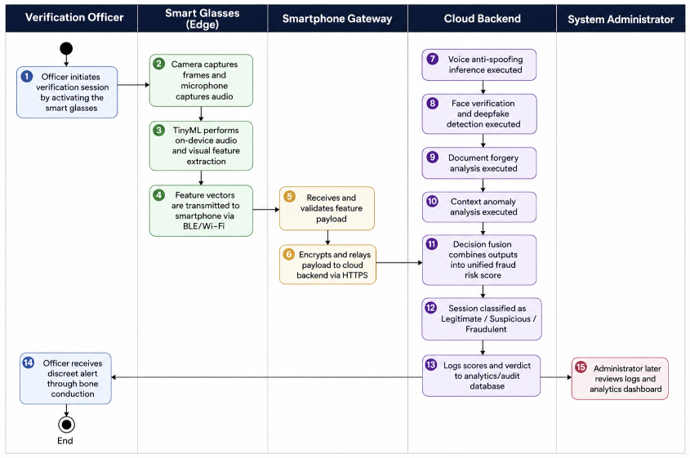

The flow proceeds as follows:

Step | Lane | Activity
1 | Officer | Officer initiates a verification session by wearing and activating the smart glasses
2 | Smart Glasses (Edge) | OV2640 camera captures continuous video frames; microphone captures audio
3 | Smart Glasses (Edge) | TensorFlow Lite Micro models run on-device: MFCC extraction for audio; visual CNN feature extraction for video
4 | Smart Glasses (Edge) | Compressed feature vectors packaged and transmitted via BLE or Wi-Fi
5 | Smartphone Gateway | Gateway app receives feature vector payload via BLE/Wi-Fi; validates integrity
6 | Smartphone Gateway | Payload encrypted and relayed to cloud backend via HTTPS REST API
7 | Cloud Backend | Voice anti-spoofing model runs inference (live vs. synthetic voice classification)
8 | Cloud Backend | Face deepfake detection + face-to-ID matching model runs in parallel
9 | Cloud Backend | Document forgery analysis model runs in parallel
10 | Cloud Backend | Context anomaly engine checks location and transaction pattern mismatches in parallel
11 | Cloud Backend | Decision fusion module aggregates all four outputs into a unified fraud risk score
12 | Cloud Backend | Interaction classified as Legitimate / Suspicious / Fraudulent
13 | Cloud Backend | Session data, scores, and verdict logged to analytics and audit database
14 | Officer | Alert delivered to officer via bone conduction speaker (discreet, real-time)
15 | Officer / Admin | Admin can later review session logs and analytics via web dashboard

Decision branch at Step 12:
- If Legitimate: session marked cleared; no alert; log entry updated
- If Suspicious: soft alert issued to officer; session flagged for manual review
- If Fraudulent: strong alert via bone conduction; session escalated; full log retained for audit

5. Work Breakdown Structure (WBS)
The WBS is organized into three levels: the project root (Level 0), six major work packages (Level 1), and individual deliverables within each package (Level 2).

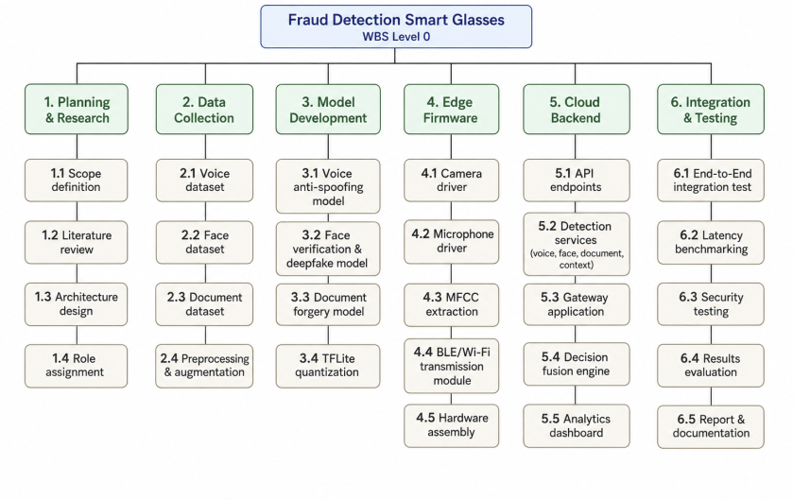

WBS ID | Work Package / Deliverable | Description
1.0 | Planning & Research
1.1 | Scope Definition | Define project boundaries, goals, and success criteria
1.2 | Literature Review | Review ASVspoof, FaceForensics++, SIDTD, TinyML literature
1.3 | Architecture Design | Design edge-gateway-cloud communication and data flow
1.4 | Role Assignment | Assign team members to modules per contributions table
2.0 | Data Collection
2.1 | Voice Dataset | Collect and prepare ASVspoof 2019/2024 dataset
2.2 | Face Dataset | Collect LFW and FaceForensics++ dataset
2.3 | Document Dataset | Collect SIDTD synthetic ID forgery dataset
2.4 | Preprocessing & Augmentation | Normalize, split, and augment all datasets
3.0 | Model Development
3.1 | Voice Anti-Spoofing Model | Train and validate voice liveness detection model
3.2 | Face Detection Model | Train face-to-ID matching and deepfake detection model
3.3 | Document Forgery Model | Train document authenticity analysis model
3.4 | TFLite Quantization | Convert and quantize models for ESP32-S3 deployment
4.0 | Edge Firmware
4.1 | Camera Driver | OV2640 integration and frame capture pipeline
4.2 | Microphone Driver | PDM mic integration and audio capture pipeline
4.3 | MFCC Extraction | On-device audio feature extraction implementation
4.4 | BLE/Wi-Fi TX Module | Wireless transmission of feature vectors to gateway
4.5 | Hardware Assembly | Physical integration of all components into glasses frame
5.0 | Cloud Backend
5.1 | API Endpoints | REST API for feature ingestion and fraud score response
5.2 | Detection Services | Voice, face, and document inference microservices
5.3 | Gateway App | Android/iOS companion app for BLE relay to cloud
5.4 | Decision Fusion Engine | Weighted multi-modal fusion and risk classification
5.5 | Analytics Dashboard | Web dashboard for admin reporting and audit logs
6.0 | Integration & Testing
6.1 | End-to-End Integration Test | Full pipeline test from glasses to cloud to alert
6.2 | Latency Benchmarking | Measure and validate sub-100ms edge extraction
6.3 | Security Testing | Encryption, data privacy, and penetration testing
6.4 | Results Evaluation | Accuracy, F1 score, FPR/FNR against benchmarks
6.5 | Final Report & Documentation | Capstone report, technical docs, and presentation

6. Gantt Chart - Task Schedule
The Gantt chart below maps all 12 major planned activities against an 18-week timeline spanning July through December. Filled (green) cells indicate active weeks for each activity.

Activity | July |  | August |  |  |  | September |  |  |  | November |  |  |  | December
Week → | 1 | 2 | 3 | 4 | 5 | 6 | 7 | 8 | 9 | 10 | 11 | 12 | 13 | 14 | 15 | 16 | 17 | 18
1. Identification, Formulation & Planning | █ | █
2. Literature Review & Technology Analysis |  | █ | █ | █
3. System Architecture Design & Communication Study |  |  |  | █ | █ | █
4. Data Collection and Preprocessing |  |  |  |  | █ | █
5. Model Development and Validation |  |  |  |  |  |  | █ | █
6. ESP32-S3 TinyML Model Testing & Calibration |  |  |  |  |  |  |  |  | █ | █ | █
7. Hardware Interfacing (Glasses Assembly) |  |  |  |  |  |  |  |  |  |  | █ | █
8. System Integration & Communication Implementation |  |  |  |  |  |  |  |  |  |  |  | █ | █ | █
9. Design Optimization (Power and Latency) |  |  |  |  |  |  |  |  |  |  |  |  |  |  | █ | █
10. Integration Testing |  |  |  |  |  |  |  |  |  |  |  |  |  |  | █ | █
11. Results Evaluation and Validation |  |  |  |  |  |  |  |  |  |  |  |  |  |  |  | █ | █
12. Final Report Preparation & Documentation |  |  |  |  |  |  |  |  |  |  |  |  |  |  |  |  | █ | █

Legend:
- Filled green cells (█) indicate the planned active weeks for each activity
- The timeline spans July (Weeks 1–2) → August (Weeks 3–6) → September (Weeks 7–10) → November (Weeks 11–14) → December (Weeks 15–18)

Key Milestones:
- Week 2 - Project scope and planning complete
- Week 6 - Literature review, architecture design, and dataset preparation complete
- Week 8 - All ML models trained and validated
- Week 11 - TinyML calibration on ESP32-S3 complete
- Week 12 - Glasses hardware assembly complete
- Week 14 - Full system integration and communication implemented
- Week 16 - Design optimization and integration testing complete
- Week 17 - Results evaluation and validation complete
- Week 18 - Final report and documentation submitted

7. Requirements Identification & Classification

7.1 Functional Requirements (FR)
ID | Requirement
FR-01 | The system shall capture real-time audio via an on-device microphone during identity verification sessions
FR-02 | The system shall capture real-time video frames via the OV2640 camera module mounted on the glasses
FR-03 | The system shall run TinyML models locally on the ESP32-S3 to extract compressed audio and visual feature vectors
FR-04 | The system shall transmit feature vectors (not raw audio/video) to the smartphone gateway via BLE or Wi-Fi
FR-05 | The smartphone gateway shall encrypt and relay feature vectors to the cloud backend via HTTPS
FR-06 | The cloud shall run voice anti-spoofing detection to identify TTS synthesis, voice conversion, and replay attacks
FR-07 | The cloud shall perform face-to-ID matching comparing the live face with the subject's registered ID photo
FR-08 | The cloud shall detect deepfake facial manipulations using a trained detection model
FR-09 | The cloud shall perform document authenticity analysis to detect digital forgeries, Moiré patterns, and synthetic printing artifacts
FR-10 | The system shall perform contextual anomaly detection including location mismatch and unusual transaction pattern analysis
FR-11 | The system shall fuse outputs from all detection modules into a single unified fraud risk score
FR-12 | The system shall classify each interaction as Legitimate, Suspicious, or Fraudulent
FR-13 | The system shall deliver discreet real-time alerts to the verification officer via bone conduction speaker
FR-14 | The system shall log all session data, risk scores, and verdicts to an analytics and audit module
FR-15 | An admin dashboard shall allow system administrators to view fraud statistics, trends, and session logs
FR-16 | Admin users shall be able to configure alert thresholds, model update parameters, and user permissions

7.2 Non-Functional Requirements (NFR)
ID | Category | Requirement
NFR-01 | Privacy | The system shall process biometric features on-device and transmit only compressed feature vectors; no raw audio or video is ever sent off-device
NFR-02 | Security | All data transmitted between edge device, gateway, and cloud shall be encrypted using TLS 1.3 / HTTPS
NFR-03 | Reliability | The system shall operate under varied lighting conditions and moderate background noise with robust preprocessing compensation
NFR-04 | Usability | Alerts shall be delivered discreetly via bone conduction without visually or audibly disrupting the officer's live interaction with the subject
NFR-05 | Scalability | The cloud backend shall support concurrent multi-session fraud detection requests across multiple deployed devices
NFR-06 | Compliance | The system shall adhere to applicable biometric data privacy regulations (GDPR, India DPDP Act 2023, or region-equivalent)
NFR-07 | Maintainability | ML models shall be updatable over-the-air without requiring a full firmware reflash of the ESP32-S3
NFR-08 | Portability | The wearable design shall integrate all components within a standard eyeglass frame form factor with minimal intrusion

7.3 Performance Requirements
ID | Requirement
PR-01 | On-device feature extraction latency: less than 100ms (TinyML inference on ESP32-S3)
PR-02 | End-to-end fraud detection latency (edge → cloud → alert): target under 2 seconds for live interactions
PR-03 | Voice anti-spoofing model accuracy shall be benchmarked against ASVspoof 2019 challenge results
PR-04 | Face verification accuracy shall target above 99% on the LFW dataset, consistent with FaceNet/ArcFace benchmarks
PR-05 | The system shall maintain stable BLE/Wi-Fi connectivity with the paired smartphone under normal indoor conditions
PR-06 | TinyML models shall fit within the ESP32-S3's available SRAM (512KB) and flash memory constraints
PR-07 | Battery life of the wearable shall support a minimum of one continuous full working shift (~8 hours) of operation

7.4 External Interface Requirements (APIs)
ID | Interface | Description
EI-01 | Cloud REST API | HTTPS endpoint accepting feature vector payloads from gateway; returning fraud risk scores and classification
EI-02 | BLE / Wi-Fi Protocol | Communication protocol (GATT profile for BLE; UDP/TCP for Wi-Fi) between ESP32-S3 and smartphone gateway
EI-03 | TensorFlow Lite Micro Runtime | On-device ML inference runtime for audio and visual feature extraction on ESP32-S3
EI-04 | OpenCV Library | Cloud-side image preprocessing for facial images and document analysis
EI-05 | FaceNet / ArcFace Model API | Face embedding and similarity scoring for face-to-ID matching service
EI-06 | ASVspoof Dataset (2019/2024) | External training and validation dataset for voice anti-spoofing model
EI-07 | FaceForensics++ Dataset | External dataset for training and evaluating deepfake detection model
EI-08 | SIDTD Dataset | Synthetic ID and Travel Document forgery dataset for document analysis model training
EI-09 | GPS / IP Geolocation API | External context service providing location data for anomaly detection
EI-10 | Analytics Dashboard (Web UI) | Web-based interface for system administrator reporting, session management, and audit log review

8. Components to be Procured

8.1 Hardware Components
# | Component | Specification / Purpose
1 | ESP32-S3 Sense Module | Dual-core Xtensa LX7 @ 240 MHz, 512 KB SRAM, 8 MB PSRAM, integrated BLE5 + Wi-Fi 802.11 b/g/n — main edge MCU for TinyML inference
2 | OV2640 Camera Module | 2MP camera integrated with ESP32-S3 Sense; JPEG compression; used for facial image and document capture
3 | MEMS Microphone Module | PDM digital microphone integrated on ESP32-S3 Sense board; used for voice audio capture
4 | Bone Conduction Transducer | Vibration-based audio transducer for discreet alert delivery to the officer without audible sound to the subject
5 | Smart Glasses Frame / Wearable Mount | Standard lightweight eyeglass frame or custom 3D-printed housing to mount all edge hardware components
6 | LiPo Battery + Power Management | Compact lithium polymer battery with power management circuit for portable wearable operation
7 | BLE / Wi-Fi Antenna | Integrated ceramic antenna on ESP32-S3 for wireless communication to smartphone gateway
8 | Gateway Smartphone (Android/iOS) | Commercial smartphone acting as BLE/Wi-Fi relay between smart glasses and cloud backend
9 | USB-C Programmer / Debugger | For firmware flashing, serial debugging, and power delivery during development
10 | Custom 3D-Printed Enclosure | Enclosure for PCB, camera, microphone, and battery to fit within glasses frame aesthetic

8.2 Software / Dataset Procurement
# | Component | Purpose
11 | Cloud Hosting (AWS / GCP / Azure) | Hosting for cloud backend API services, ML inference microservices, and analytics database
12 | SSL/TLS Certificate | Secure HTTPS communication between gateway and cloud
13 | ASVspoof 2019 / 2024 Dataset (open access) | Voice anti-spoofing model training and benchmarking
14 | FaceForensics++ Dataset (licensed) | Deepfake face detection model training and evaluation
15 | SIDTD Synthetic ID Dataset | Document forgery detection model training and evaluation

9. Technology Stack

9.1 Hardware Stack
Layer | Component | Technology
Edge MCU | Main microcontroller | ESP32-S3 Sense — Xtensa LX7 dual-core @ 240 MHz, 512 KB SRAM, 8 MB PSRAM
Capture — Visual | Camera | OV2640 (2MP, JPEG, integrated on ESP32-S3 Sense)
Capture — Audio | Microphone | PDM MEMS microphone (integrated on ESP32-S3 Sense)
Output | Alert system | Bone conduction transducer (vibration-based discreet audio)
Gateway | Relay device | Android or iOS smartphone (BLE/Wi-Fi companion app)
Communication | Wireless | BLE 5.0 (GATT profile) and Wi-Fi 802.11 b/g/n

9.2 Edge Software Stack
Component | Technology | Purpose
Firmware Language | C / C++ (ESP-IDF / Arduino framework) | Low-level firmware for peripherals, ML runtime, and communication
ML Inference Runtime | TensorFlow Lite Micro (TFLite Micro) | On-device inference for audio and visual feature extraction
Audio Feature Extraction | Custom MFCC implementation in C | Mel-Frequency Cepstral Coefficient extraction from raw audio
Visual Feature Extraction | Lightweight CNN (TFLite quantized) | Face feature vector extraction from OV2640 frames
Wireless Communication | BLE GATT profile / Wi-Fi UDP-TCP | Transmission of feature vectors to smartphone gateway

9.3 Gateway App Stack
Component | Technology | Purpose
Platform | Android (Kotlin) / iOS (Swift) | Native companion app for the gateway relay layer
BLE Stack | Android BLE API / Core Bluetooth (iOS) | Receive feature vectors from ESP32-S3 over BLE
Cloud Relay | Retrofit (Android) / URLSession (iOS) over HTTPS | Encrypt and forward feature vectors to cloud backend API
Security | TLS 1.3 + certificate pinning | Secure end-to-end relay from glasses to cloud

9.4 Cloud Backend Stack
Component | Technology | Purpose
Backend Language | Python 3.11+ | Primary language for all cloud services and ML integration
API Framework | FastAPI | High-performance REST API for feature ingestion and fraud score response
Voice Anti-Spoofing Model | Transformer (wav2vec 2.0 / HuBERT) fine-tuned on ASVspoof 2019/2024 | Live vs. synthetic voice classification
Face Verification | FaceNet / ArcFace (PyTorch or TensorFlow) | Face embedding generation and face-to-ID similarity scoring
Deepfake Detection | CNN fine-tuned on FaceForensics++ | Binary classification of real vs. manipulated facial images
Document Analysis | OpenCV + CNN (Moiré + forgery detection) | Detect Moiré patterns, digital forgeries, and synthetic artifacts in ID documents
Context Anomaly Engine | Rule-based engine + lightweight ML anomaly scorer | Flag location mismatches and unusual transaction patterns
Decision Fusion | Weighted ensemble / voting classifier | Combine all module outputs into unified fraud risk score
Database | PostgreSQL | Session data, audit logs, fraud verdicts, and user management
Analytics Dashboard | Grafana / custom React dashboard | Admin-facing web interface for reporting and audit trail
Containerization | Docker + Docker Compose | Containerized deployment of all backend microservices
Cloud Platform | AWS / GCP / Azure | Hosting, auto-scaling, and managed database services

9.5 Training Datasets
Purpose | Dataset | Key Characteristics
Voice anti-spoofing | ASVspoof 2019 & 2024 | Covers TTS synthesis, voice conversion, replay attacks; global benchmark
Face verification accuracy | LFW (Labeled Faces in the Wild) | Standard face verification benchmark; FaceNet achieves 99.63%
Deepfake face detection | FaceForensics++ | High-quality deepfake dataset with compression variants; domain-specific training
Document forgery detection | SIDTD (Synthetic ID and Travel Documents) | Synthetic ID forgery dataset for document PAD model training (2024)

9.6 Summary Technology Table
Layer | Primary Technology
Edge hardware | ESP32-S3 Sense (Espressif)
Edge ML runtime | TensorFlow Lite Micro
Edge firmware | C / C++ (ESP-IDF)
Gateway app | Android (Kotlin) / iOS (Swift)
Cloud API | Python + FastAPI
Cloud ML | PyTorch / TensorFlow (FaceNet, ArcFace, wav2vec)
Computer vision | OpenCV
Database | PostgreSQL
Infrastructure | Docker + AWS/GCP/Azure
Analytics | Grafana / React dashboard

